|  |  |  |
| --- | --- | --- |
| **DRAFTING** | **QSA** | **Nicola Parmeggiani** |
| **CHECK** | **QAM** | **Alberti Massimiliano** |
| **APPROVAL** | **QAM** | **Alberti Massimiliano** |

|  |  |  |
| --- | --- | --- |
| LIST OF CHANGES | | |
| Rev. N. | Date | Description |
| 00 | 12/13/2024 | First issue |
|  |  |  |

Summary

1 SCOPE 2

2 Scope of application 2

3 TASKS AND RESPONSIBILITIES 2

4 OPERATING MODES 2

4.1 IMPURITIES DETECTION PROCEDURE 2

4.2 SOLVENT WASHING METHOD PROCEDURE FOR DETECTING IMPURITIES IN PRODUCTION 3

5 ACCEPTABILITY CRITERIA 5

5.1 Sizes and weights of impurities 5

5.2 Mating surfaces in contact 5

5.3 Cleaning fluids and cleaning devices 5

5.4 Lubricating fluids and application tools 6

5.5 Work/transport equipment 6

# SCOPE

* Define the methods for detecting the quantity and grain size of solid impurities present on components to be assembled with greater attention to sealing systems.
* Specify the quantity and maximum permissible particle sizes of impurities during production and during acceptance of washing systems.

# Scope of application

This standard applies to all assembled sealing systems, as well as to all components intended for subsequent assembly.

# TASKS AND RESPONSIBILITIES

T&I staff is responsible for designing components by evaluating the appropriate washing conditions during industrialization.

# OPERATING MODES

## IMPURITIES DETECTION PROCEDURE

The values ​​of the residual impurities, identified with the procedures described below, must fall within the acceptability limits defined in the following points.

**Note:** Before carrying out the cleaning checks, as indicated below, it must be visually checked that the pieces are free from shavings or other residues; only if no shavings or other impurities have been identified can the laboratory check be carried out.

## SOLVENT WASHING METHOD PROCEDURE FOR DETECTING IMPURITIES IN PRODUCTION

* + 1. Collect the component on board the washing system unloading station, taking care to handle the pieces with special clean PVC gloves and to seal them individually in new bags or perfectly clean containers, for transport to the analysis laboratory.

In the case of BUY components, the pieces must be taken in the original packaging condition. In the case of treatments that may affect the outcome of the control, arrange for the sample to be taken from the supplier before applying the protective treatment.

In cases of Process Audit of MAKE elements, the parts must be taken from the assembly line in the assembly condition.

* + 1. In the laboratory, wear clean PVC gloves during each phase of the process. Place the part to be checked on a thoroughly cleaned surface, removing its protective wrapping.
    2. Transfer the component to be tested into the appropriate clean room or into a stainless steel tank thoroughly cleaned with solvent.
    3. Perform any external beating of the component, if necessary, for a period of approximately 1 minute, acting only on the rough parts or flat surfaces using a polyethylene (PET) hammer of adequate size (see example photo “B”).

PHOTO EXAMPLE “B”

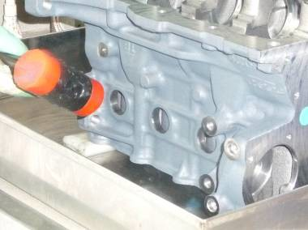

* + 1. Proceed to wash all the unsealed parts of the component using the product “Petroleum ether” or equivalent (example “Desodo 50”). An important characteristic is that the product used is a solvent and not a detergent. In the case of components supplied “oiled” or with particular protective treatments, use, if possible, instead of the solvent, distilled water or a product suitable for removing impurities without causing the removal of the oil or the protective and without causing damage to the part itself. Wash the piece thoroughly, carefully cleaning all its parts (blind holes, through holes, chambers, etc.), with a spray bottle or, where applicable, a clean room with a special gun at a pressure of approximately 5 bar (see photo example “C”).

PHOTO EXAMPLE “C”

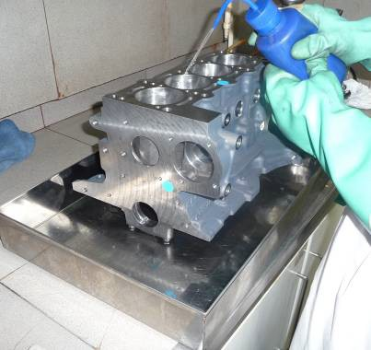

Once washing is complete, move the component onto a thoroughly cleaned surface and transfer the solvent and impurities collected into a previously cleaned and appropriately identified polythene container, washing the tray thoroughly to completely collect the residues.

* + 1. Transfer the component back into a perfectly clean stainless steel tray or clean room.
    2. Condition the Millipore filters (porosity 30 µm) in a thermostatic oven at 40 ± 2°C for 1 hour, then cool them in a 300 mm diam. glass desiccator (or in any case treat them in a desiccator to deprive them of humidity) and weigh them with an analytical balance (precision ± 0.1 mg) to obtain the weight “A” (tare).
    3. Insert the filter into the vacuum filtration apparatus, consisting of: filter bell, sintered glass or stainless steel disc, connecting funnel, tailed flask, suitable for inserting Millipore filters.
    4. Filter, with moderate vacuum (or by gravity), the contents of the polythene/stainless steel container with the collected impurities, washing it carefully with “Petroleum ether” or equivalent (see point 4.2.5).
    5. Visually analyze the residues present on the Millipore filters, using a microscope or an optical instrument with at least 25x magnification (e.g. Nicon stereoscopic microscope with motorized system), and remove, if necessary, all materials not subject to the cleaning check (e.g. plastic residues and organic fibers) using stainless steel tweezers.
    6. Recondition the filters in a thermostatic oven at 40 ± 2°C for 2 hours, leaving them to cool in a desiccator.
    7. Weigh the filters with the impurities on an analytical balance (precision ± 0.1 mg – See example photo “F”) and, subtracting the tare “A”, evaluate the weight of the solid impurities found.

PHOTO EXAMPLE “F”

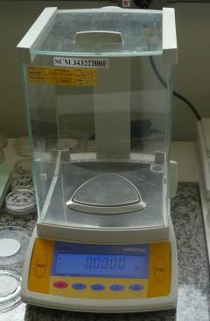

* + 1. Subsequently, if required by the tables of acceptability limits “A, B, C and D” included in this standard, proceed to measure the particle size.

To evaluate the maximum size of impurities, it is recommended to use a lattice microscope with magnification up to 20x equipped with a graduated scale suitable for measuring the particles present on the Millipore filter (See example photo “G”).

PHOTO EXAMPLE “G”

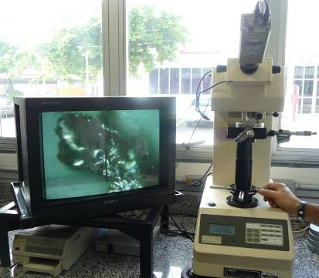

Alternatively, an image processing and archiving system (Nis Elements) can be used with software for the automatic counting of residual metallic and non-metallic particles and fibres on filter membranes, according to ISO 16232 (NIS-FILTER) with:

* automatic discrimination of metallic particles from organic ones
* automatic measurement and discrimination of particles based on size.

# Acceptability criteria

## Sizes and weights of impurities

|  |  |  |  |
| --- | --- | --- | --- |
| 1 | 2 | 3 | 4 |
| Maximum allowable part sizes | Maximum weight of permitted parts | Maximum number of particles allowed | Type of possible contaminants allowed |
| Max 1,200 μm | Max 600 mg/m² | **\***Max 3 pcs (size: 1,000~1,200 μm) | **\***Organic contaminants |

**\***Organic contaminants are materials derived from paper, fabrics or natural polymers, of which a maximum of 3 pieces are permitted and of a size between 1,000~1,200 μm, corresponding to 1~1.2 mm.

**\*Metal contaminants, NOT ALLOWED** and are understood to be impurities or residues composed of metals or metal alloys, which may derive from production processes, wear of machinery or accidental contamination

**\*Non-metallic contaminants, NOT ALLOWED** such as polymers, rubber, paints, synthetic fibres.

## Mating surfaces in contact

The presence of contaminating elements of any nature and size, detectable by the naked eye, on machined mating or contact parts is not permitted..

## Cleaning fluids and cleaning devices

The presence of contaminants of any nature and size, both in the fluids used for cleaning and in the devices used for their application, detectable visually, is not permitted.

## Lubricating fluids and application tools

It is essential that the greases, lubricants and adhesives used for couplings, as well as the devices used for their application, are visually free from contaminants of any nature or size.

## Work/transport equipment

The presence of contaminants of any nature and size that can be visually detected on the parts of the handling equipment/containers in direct contact with the components or that can cause contaminants to fall onto the components is not permitted.